SYD366 – Individual Assignment
Deliverables:
- One .vpp file that includes 1 class diagram and 2 sequence diagrams
- One word compatible file that includes pictures of your class diagram, sequence diagrams, screenshots and your reflection.
One of the best ways to see if you really understand modelling is to reverse engineer an app or a website. Your professor won’t be downloading 40 different apps, so we will focus on websites for this assignment.
Please choose from one of the following websites. Each group member must choose a different website. Your professor will post a ‘sign-up’ sheet in your group’s workspace for you to edit. Students who don’t post their website choice 24 hours prior to the assignment due date, will be penalized with a 20% deduction.
Website Choices:
Lowes.ca
Reitmans.com
Marymaxim.ca
https://canada.michaels.com
canadiantire.ca
dell.com
staples.ca
timhortons.ca

In your class diagram and sequence diagrams you must document the signup process and creating an order for goods or a service. You must use one class diagram for the whole project and separate sequence diagrams for the signup process and creating an order. Some websites are designed in such a way that the processes look like one long process, but please break it up so that your diagrams are not huge. We will not be documenting paying for an order.
Please include screenshots of the website, documenting the processes. Also, please document why you chose this website for this assignment, what you like about the website and what you would change if you were the designer.
Your submitted files must include all contact information as specified by the course policies.

ANSWER:
TOPIC: TIM HORTONS
USE CASE DIAGRAM
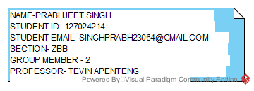
CLASS DIAGRAM
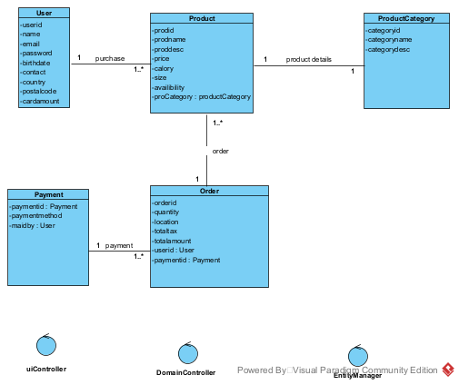
SEQUENCE DIAGRAM
SIGN UP
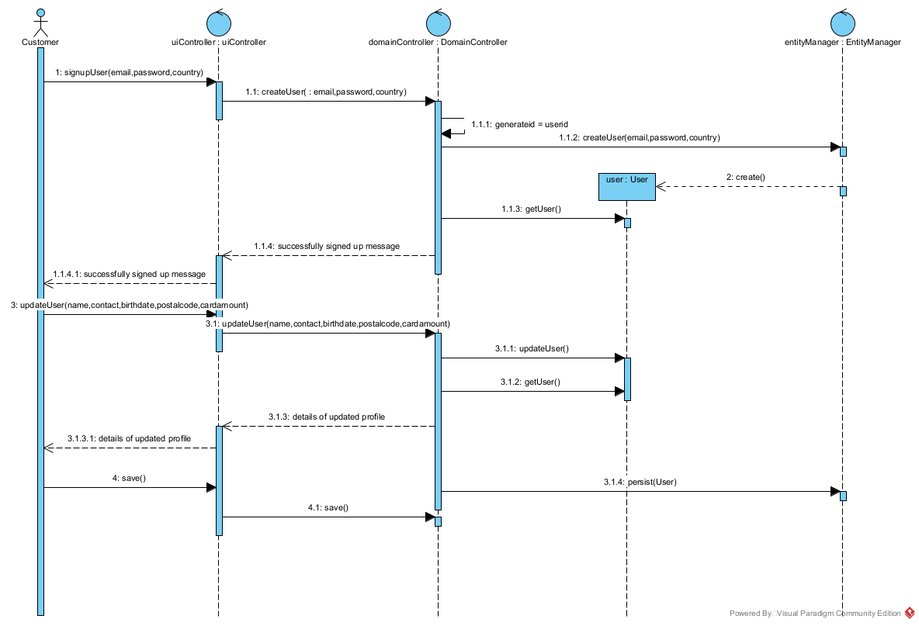
ORDER
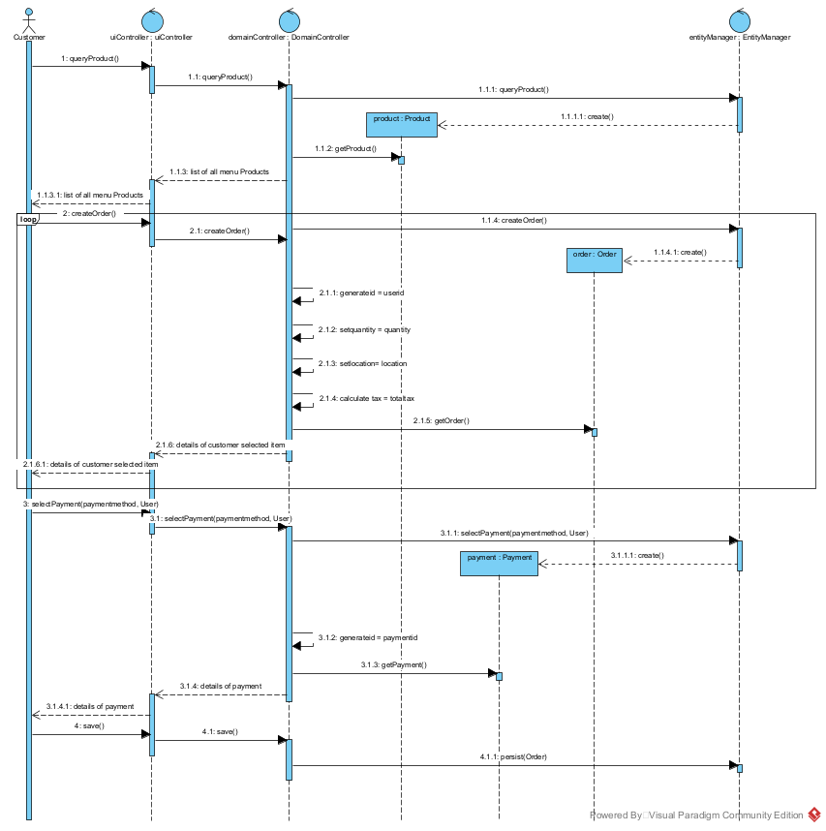

SCREENSHOTS OF SIGNUP AND ORDER PURCHASE DETAILS
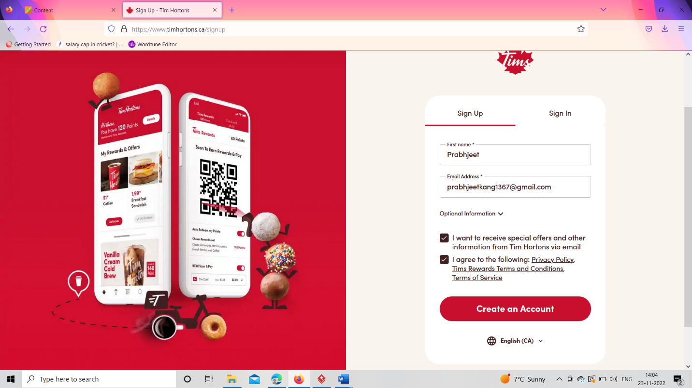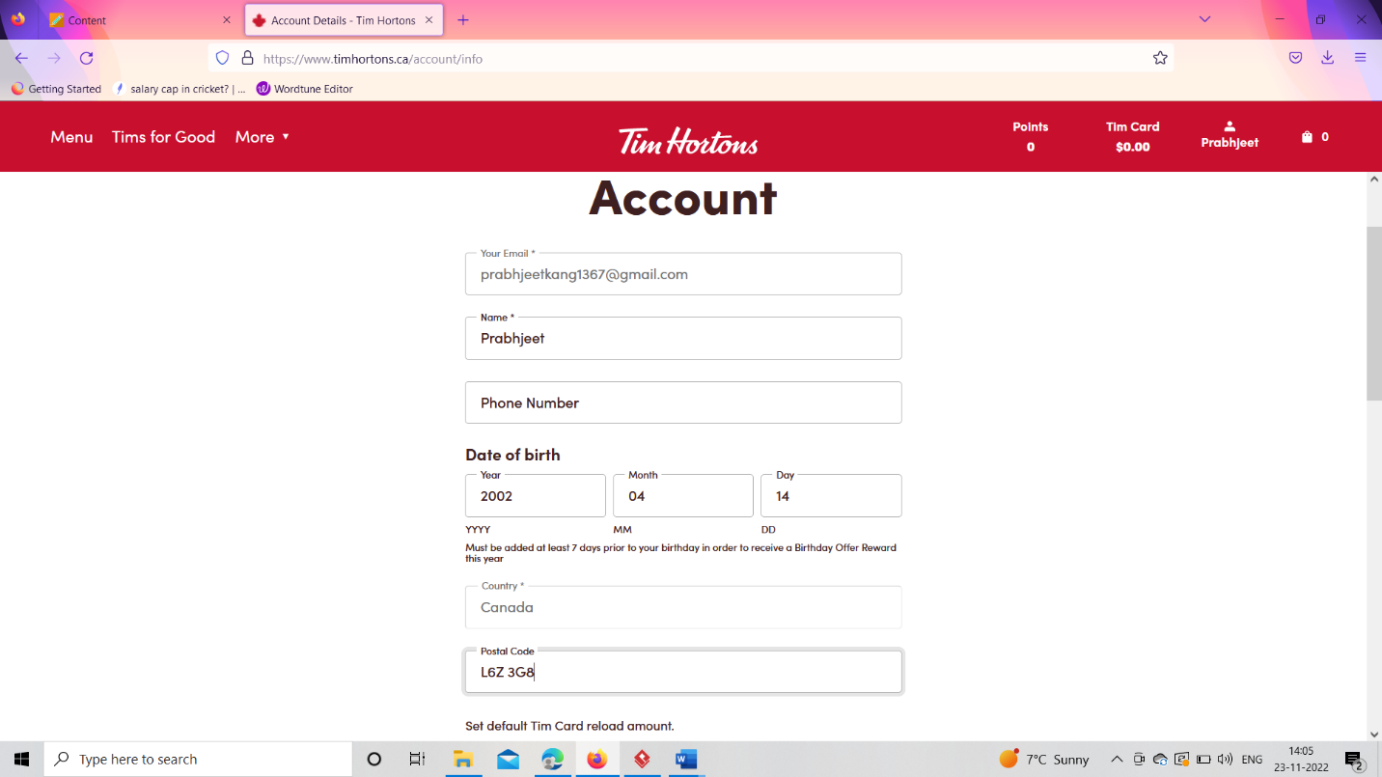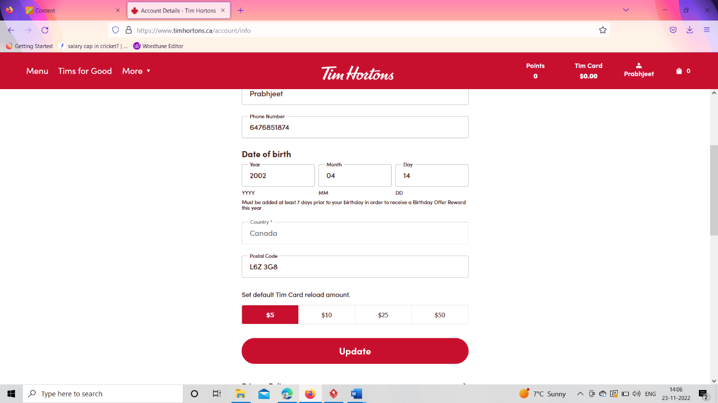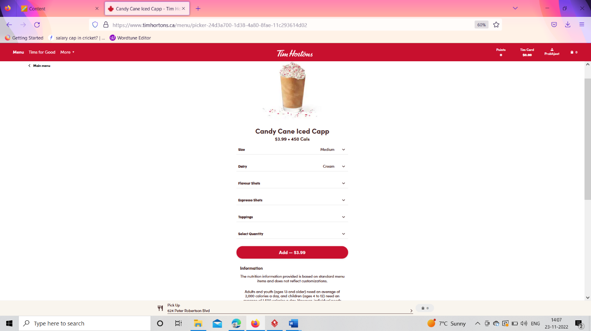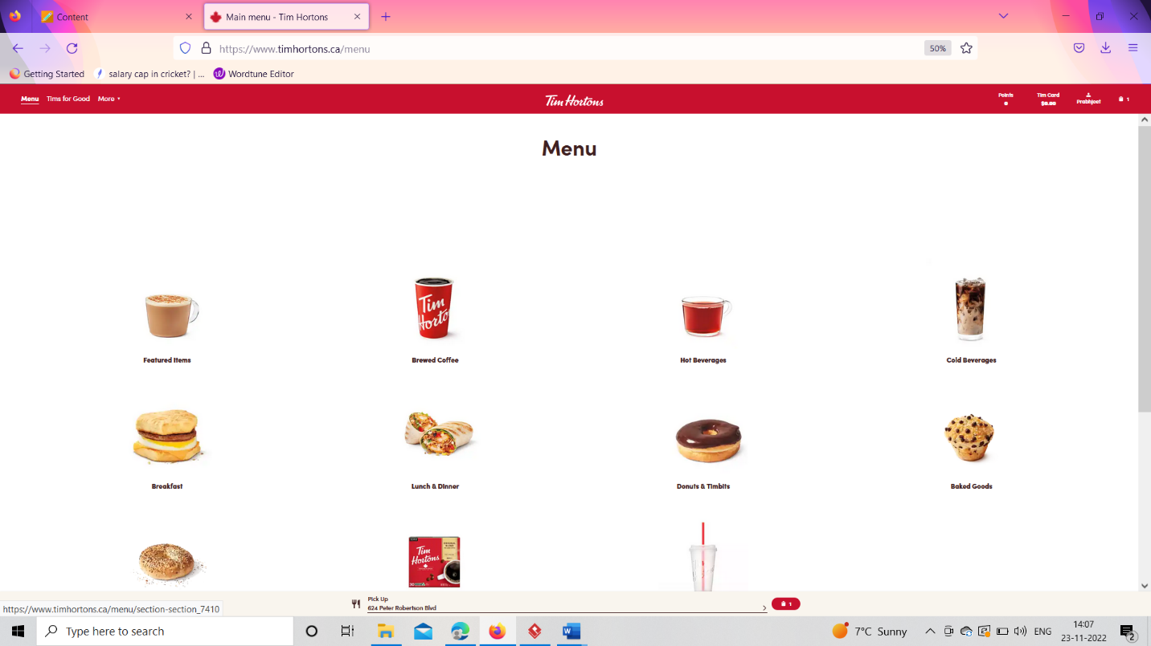
REFLECTION:
Tim Hortons is one of the biggest Canadian companies with the most popular serving menu items such as Coffees and many more items. It was founded in 1964 in Hamilton, Ontario, Canada. I choose the brand for my assignment because I have been using Tim Hortons almost every day of my life. Whenever I go to college or work, I will buy coffee and some breakfast to eat with it. When we go to their website design it is great we can choose the option to get delivered to our address and choose our item from a great menu. Even at their if we have any promo code we can apply it and have a discount. Our rewards card is automatically created by the system, which gives us points whenever we use it for purchase. Moreover, to add, we have lots of options to add for payment such as debit, credit, visa, etc.
If I am going to make any change in the app design I would focus on how the items are shown, for example, the system should suggest customer a combo according to what time of the day it is and for how many people they are going to order. As, if it is in the morning, the system should suggest an automatically generated combo for breakfast according to any preferred idea. Also, I would create the option to divide the items into two categories such as veggie and non-veggie, as if the customer wants to eat veggie, then the system will show the veggie options available.

